Try and imagine what might have been happening just before this photograph was taken. Draw what you think happened in the empty box. You can use speech or thought bubbles to help explain your picture.

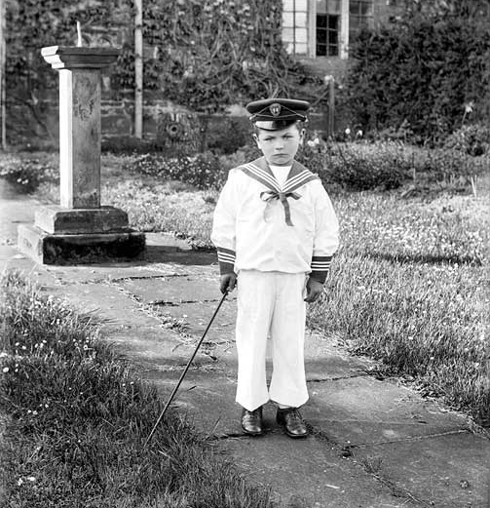

This worksheet relates to the ‘What do you think happened just before this photograph was taken?’ Teaching Activity

